SMARTBIN K17 |  | Kelompok 17  Manual Book  Model :  SmartBin  Tong Sampah Otomatis Berbasis Arduino | 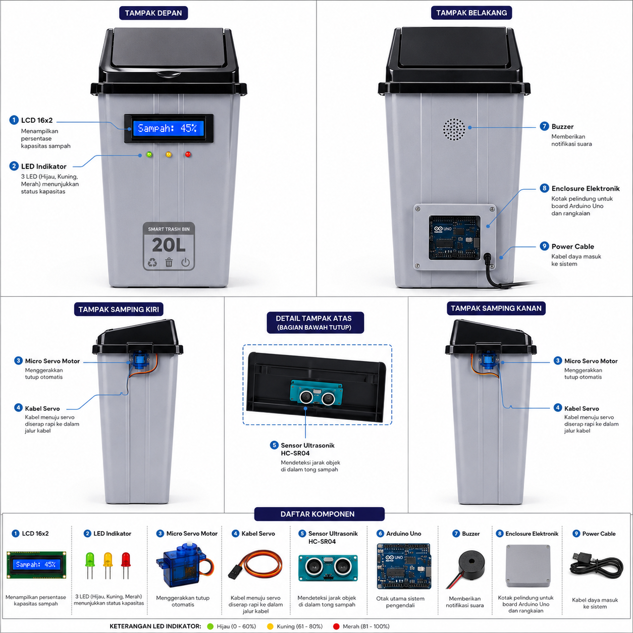

Kelompok 17  Layanan Dukungan (Support)  E-mail :  Web : | No. Dok : IM-SB001/0 | Tgl. Efektif : 30 Agustus 2026

Spesifikasi Produk
SmartBin adalah tong sampah otomatis berbasis Arduino Uno yang mendeteksi kehadiran objek di depan tutupnya, lalu membuka tutup secara otomatis memakai motor servo. Alat ini mengukur ketinggian sampah memakai sensor ultrasonic, menampilkan persentase kapasitas di layar LCD, lengkap dengan indikator LED hijau, kuning, dan merah.
Gambar 1. Tampilan fisik SmartBin dari berbagai sisi
Spesifikasi Umum
Kapasitas tong | 20 liter
Tinggi tong | ± 40 cm
Sumber daya | Adaptor 9V
Pengendali utama | Arduino Uno R3
Sensor | Ultrasonic HC-SR04 & Infrared
Output | LCD 16x2 I2C, LED 3 warna, Buzzer, Servo SG90
Daftar Komponen
No | Nama Komponen | Jml | No | Nama Komponen | Jml
1 | Adaptor Arduino 9V | 1 buah | 10 | Motor Servo SG90 | 2 buah
2 | Arduino Uno R3 | 1 buah | 11 | Resistor 220 Ohm | 3 buah
3 | Enclosure Arduino R3 V3 | 1 buah | 12 | Resistor 330 Ohm | 3 buah
4 | Buzzer Passive | 2 buah | 13 | Cable Screw Mount | 1 pack
5 | Bezel LCD 16x2 | 1 buah | 14 | Sensor Ultrasonic HC-SR04 | 1 buah
6 | Sensor Infrared | 2 buah | 15 | Timah Solder 10 m | 1 gulung
7 | Kabel Serabut NYAF 5 m | 1 gulung | 16 | Tong Sampah 20 liter | 1 buah
8 | LCD 16x2 I2C | 1 buah | 17 | Baut Mur M5 x 10mm | 1 pack
9 | LED (Merah,Kuning,Hijau) | 3 buah | 18 | Plat Baja 0,5 mm | 2 buah
Pemetaan Pin ke Arduino Uno
• Sensor Infrared (IR) → pin D2
• Sensor Ultrasonic HC-SR04 → pin D3 (trig), pin D4 (echo)
• LED Hijau / Kuning / Merah → pin D5 / D6 / D7
• Buzzer → pin D8
• Motor Servo SG90 → pin D9
• LCD 16x2 I2C → jalur SDA & SCL (alamat I2C 0x20)

Petunjuk Keamanan
Sebelum menggunakan SmartBin, baca seluruh petunjuk berikut dengan seksama dan pergunakan dengan benar.
Arti Simbol
• (X) Larangan: hal ini tidak boleh dilakukan.
• (!) Peringatan: perhatikan dengan seksama sebelum melanjutkan.
• (~) Bahaya sengatan listrik: hindari kontak dengan air atau tangan basah.
Perhatian untuk Keamanan
• Pastikan adaptor 9V yang dipakai sesuai kebutuhan Arduino Uno, jangan gunakan adaptor bertegangan lebih tinggi.
• Matikan daya sebelum membongkar-pasang komponen atau kabel di dalam enclosure.
• Jauhkan rangkaian elektronik dari air atau cairan, terutama bagian dalam tong dekat sampah basah.
• Jangan menahan atau menghalangi gerakan tutup tong secara paksa saat servo bekerja, agar servo tidak rusak.
• Cek semua sambungan kabel sebelum menyalakan alat, pastikan tidak ada kabel terkelupas atau short.
• Jauhkan alat dari jangkauan anak kecil tanpa pengawasan, terutama bagian servo yang bergerak.

Informasi Rangkaian
SmartBin dikirim dalam kondisi sudah terpasang penuh dan siap pakai, bagian ini hanya sebagai informasi tambahan mengenai rangkaian internal di dalamnya, berguna bila suatu saat diperlukan servis atau pengecekan.
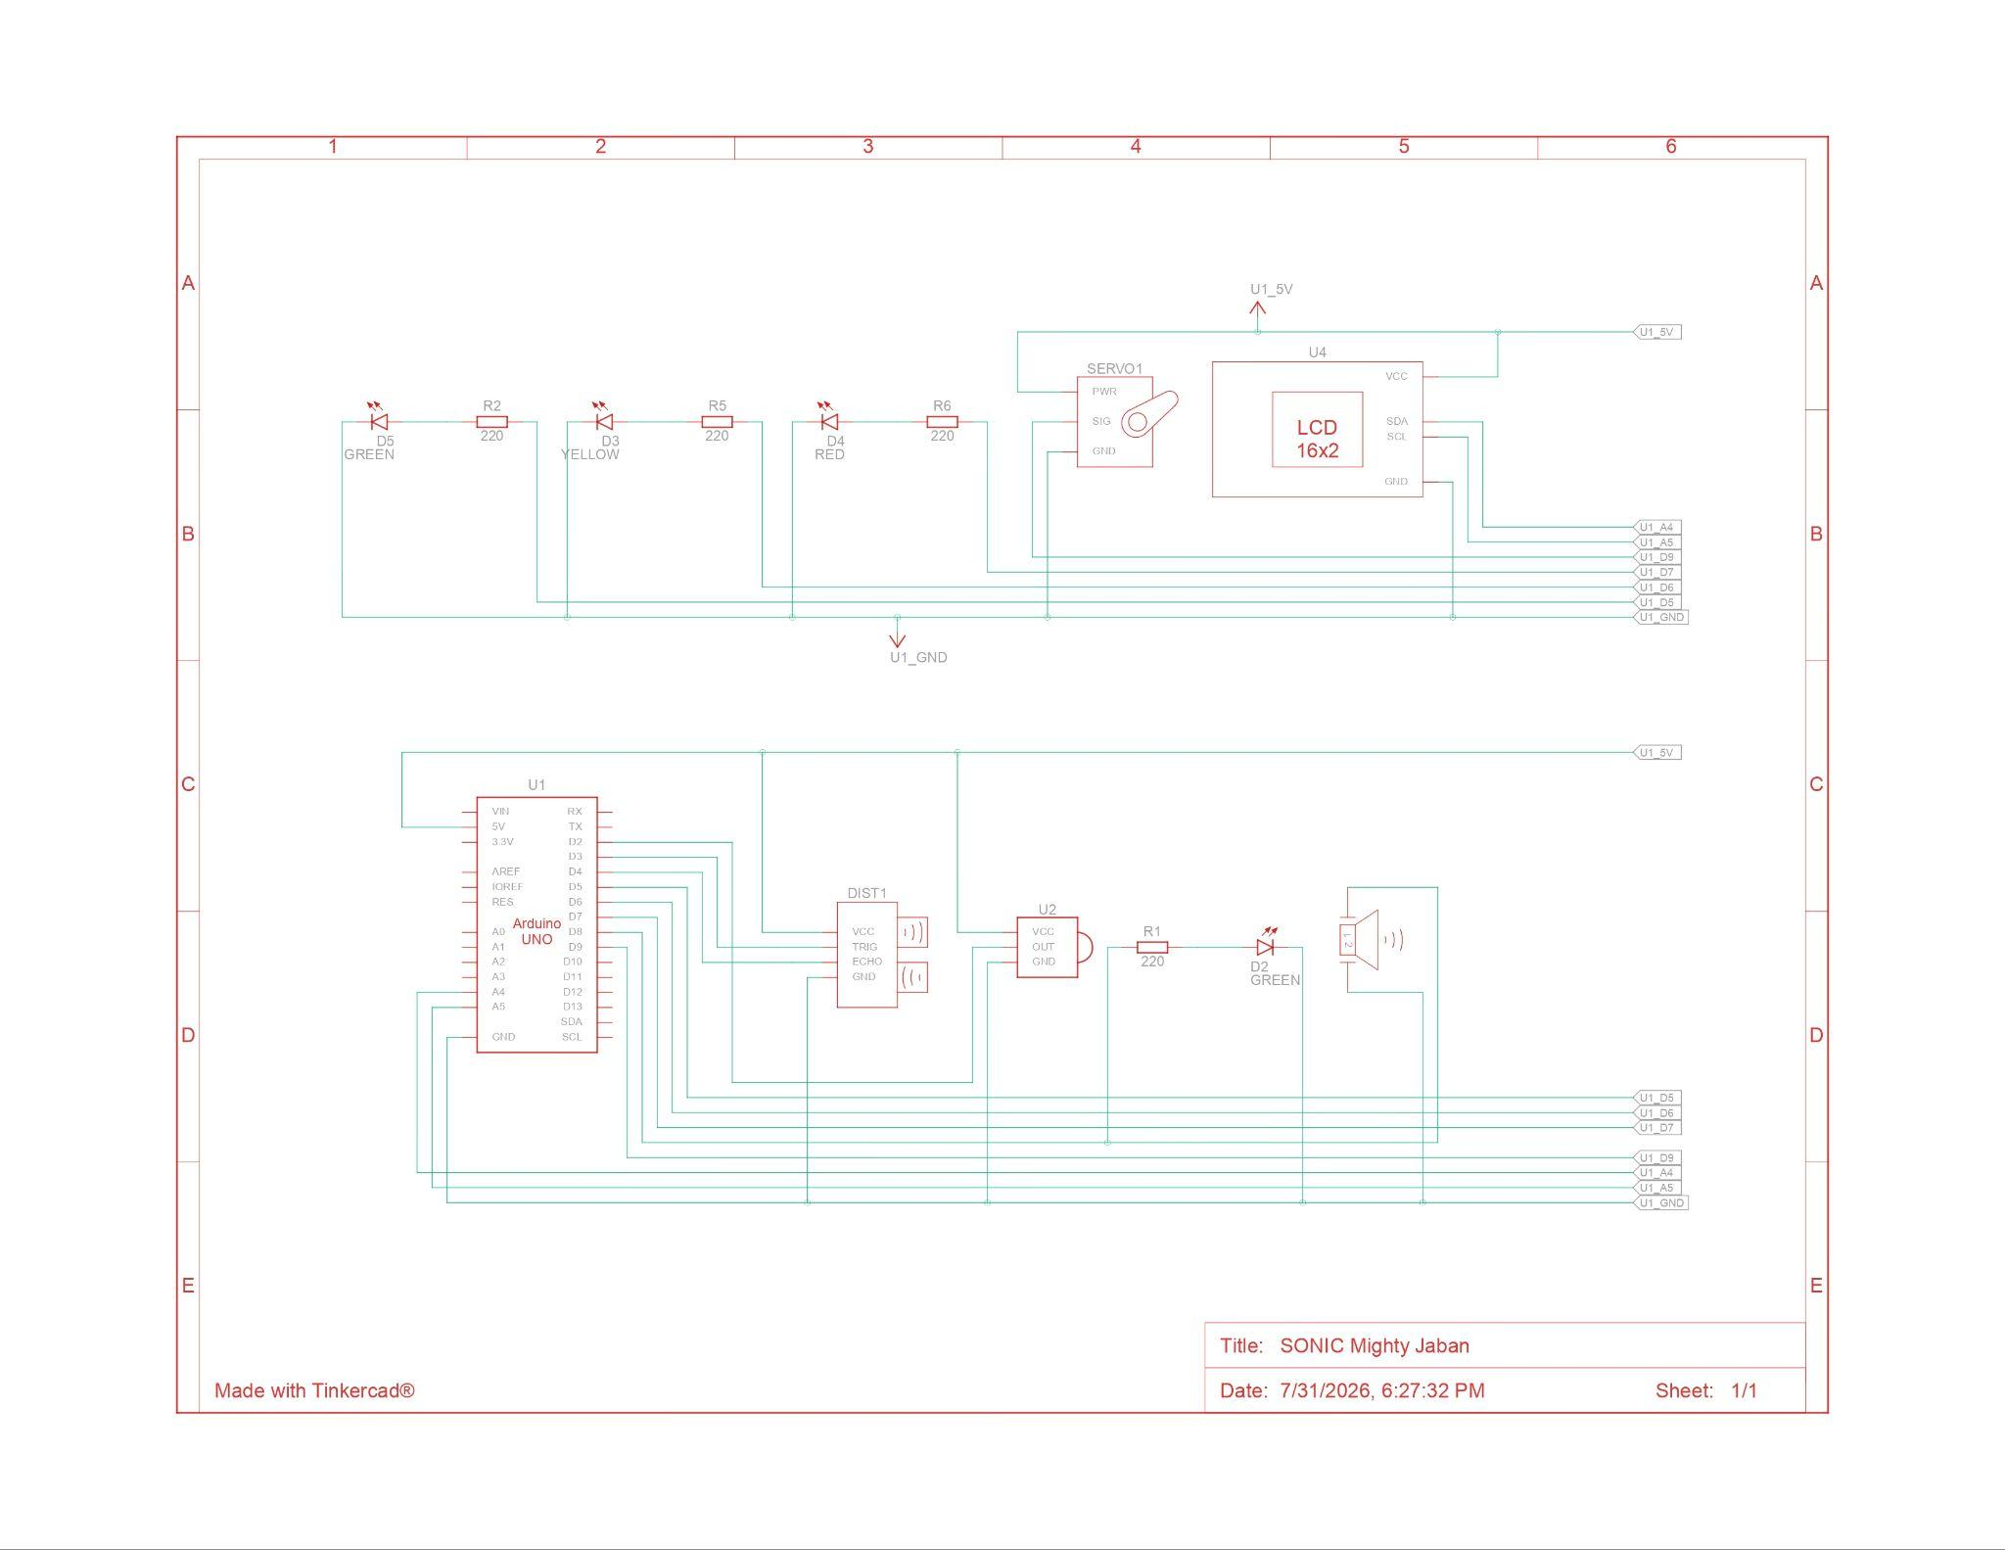
Gambar 2. Skema rangkaian SmartBin
Tata Letak Komponen
• Arduino Uno ditempatkan dalam enclosure pelindung di bagian belakang tong.
• Sensor ultrasonic HC-SR04 terpasang di bagian bawah tutup, menghadap ke dalam tong untuk membaca kapasitas sampah.
• Sensor infrared terpasang di mulut tong, menghadap keluar untuk mendeteksi tangan/objek yang mendekat.
• Motor servo terpasang di engsel tutup, terhubung ke mekanisme buka-tutup otomatis.
• LCD 16x2 I2C dan tiga LED indikator berada di bagian depan tong, terlihat langsung oleh pengguna.
• Buzzer terpasang di bagian belakang tong untuk memberi notifikasi suara.
• Seluruh kabel sudah dirapikan memakai cable screw mount dan disambungkan ke adaptor 9V, tinggal colok dan pakai.

Petunjuk Pengoperasian
Cara Kerja Sistem
Alur kerja SmartBin dimulai dari dua sensor yang membaca kondisi tong, lalu Arduino Uno mengolah data tersebut untuk mengatur seluruh output.
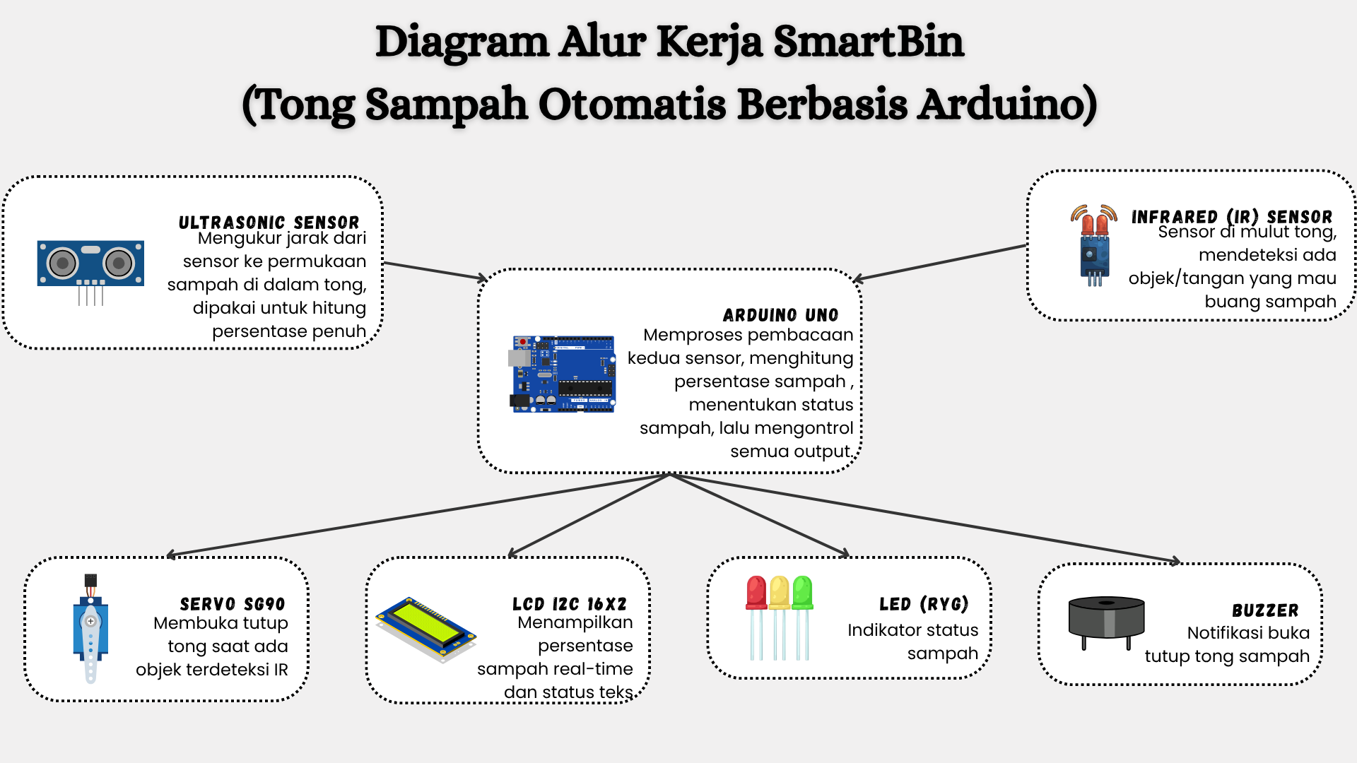
Gambar 3. Diagram alur kerja SmartBin
Sensor infrared (pin D2, mode INPUT_PULLUP) mendeteksi tangan/objek di mulut tong dan memicu servo membuka tutup. Sensor ultrasonic HC-SR04 (trig D3, echo D4) mengukur jarak ke permukaan sampah; bila sinyal gagal terbaca dalam 30 ms, tong dianggap kosong.
Servo SG90 (pin D9) bergerak ke 90° untuk membuka tutup, tertahan 2 detik, lalu kembali ke 0°. LED hijau (D5) menyala saat kosong, kuning (D6) saat hampir penuh, merah (D7) saat penuh.
Cara Pengoperasian
1. Colokkan adaptor 9V ke SmartBin, tunggu LCD menampilkan “Smart Bin Ready”.
2. Dekatkan tangan/objek ke sensor infrared di mulut tong untuk membuka tutup.
3. Tutup akan otomatis menutup kembali setelah 2 detik.
4. Perhatikan LCD dan LED untuk status kapasitas: hijau = kosong, kuning = hampir penuh, merah = penuh.
5. Bila status penuh (merah), tutup tidak akan terbuka sampai tong dikosongkan.

Petunjuk Perawatan
Merawat SmartBin
• Bersihkan sensor ultrasonic dan infrared secara berkala dari debu/kotoran agar pembacaan tetap akurat.
• Cek kondisi baut dan mur penyangga servo, kencangkan kembali bila mulai kendor.
• Jangan biarkan tong kepenuhan air/cairan karena dapat merusak rangkaian di dalamnya.
• Lap bagian LCD dan enclosure dengan kain kering, hindari cairan pembersih langsung ke rangkaian.
• Kosongkan tong secara rutin agar sensor ultrasonic tetap dapat membaca kondisi kosong dengan benar.
Mengatasi Masalah
Perhatian! Jangan membongkar rangkaian sendiri bila belum yakin, ikuti dahulu petunjuk berikut.
• LCD tidak menyala: cek sambungan SDA/SCL, pastikan alamat I2C sesuai kode program (0x20).
• Tutup tidak mau terbuka: cek status tong (servo tidak bergerak bila sudah penuh) atau sambungan sensor infrared di pin D2.
• Persentase LCD tidak akurat: cek posisi & kebersihan sensor ultrasonic, pastikan menghadap lurus ke permukaan sampah.
• Servo bergerak terus/bergetar: cek daya adaptor 9V, servo yang kekurangan daya biasanya bergetar.
• Buzzer tidak berbunyi: cek sambungan kabel pin D8 dan polaritas buzzer.

Lampiran: Kode Program (Firmware)
Berikut kode program lengkap yang digunakan pada Arduino Uno untuk menjalankan SmartBin.
#include <Wire.h>
#include <LiquidCrystal_I2C.h>
#include <Servo.h>

LiquidCrystal_I2C lcd(0x20, 16, 2);
Servo servo1;

const int irpin = 2;
const int trig = 3;
const int echo = 4;
const int servopin = 9;
const int ledh = 5;
const int ledk = 6;
const int ledm = 7;
const int buzz = 8;

// ukuran tong
const int tinggi = 40; // jarak pas kosong (cm)
const int batasfull = 5; // jarak pas penuh (cm)

int level = 0; // 0 kosong, 1 hampir penuh, 2 penuh
int persen = 0;
bool irlast = HIGH;

long bacajarak() {
digitalWrite(trig, LOW);
delayMicroseconds(2);
digitalWrite(trig, HIGH);
delayMicroseconds(10);
digitalWrite(trig, LOW);
long durasi = pulseIn(echo, HIGH, 30000);
if (durasi == 0) return tinggi;
long jarak = durasi * 0.034 / 2;
return jarak;
}

int hitungpersen(long jrk) {
jrk = constrain(jrk, batasfull, tinggi);
int p = map(jrk, tinggi, batasfull, 0, 100);
return constrain(p, 0, 100);
}

void setup() {
Serial.begin(9600);
pinMode(irpin, INPUT_PULLUP);
pinMode(trig, OUTPUT);
pinMode(echo, INPUT);
pinMode(ledh, OUTPUT);
pinMode(ledk, OUTPUT);
pinMode(ledm, OUTPUT);
pinMode(buzz, OUTPUT);
servo1.attach(servopin);
servo1.write(0);
lcd.init();
lcd.backlight();
lcd.setCursor(0, 0);
lcd.print("Smart Bin Ready");
delay(1500);
lcd.clear();
updatelcd();
}

void loop() {
int irnow = digitalRead(irpin);
long jrk = bacajarak();
persen = hitungpersen(jrk);

Serial.print("ir: "); Serial.print(irnow);
Serial.print(" jarak: "); Serial.print(jrk);
Serial.print("cm persen: "); Serial.print(persen);
Serial.println("%");

if (persen >= 71) level = 2;
else if (persen >= 31) level = 1;
else level = 0;

if (irnow == LOW && irlast == HIGH && level != 2) {
buka();
}
irlast = irnow;

updatelcd();
delay(200);
}

void buka() {
lcd.clear();
lcd.setCursor(0, 0);
lcd.print("Sampah Terbuka");
digitalWrite(ledh, HIGH);
tone(buzz, 1000, 200);
servo1.write(90);
delay(2000);
lcd.setCursor(0, 1);
lcd.print("Menutup...");
servo1.write(0);
tone(buzz, 1000, 200);
digitalWrite(ledh, LOW);
delay(500);
lcd.clear();
}

void updatelcd() {
lcd.setCursor(0, 0);
lcd.print("Sampah: ");
lcd.print(persen);
lcd.print("% ");
lcd.setCursor(0, 1);
digitalWrite(ledh, LOW);
digitalWrite(ledk, LOW);
digitalWrite(ledm, LOW);
if (level == 2) {
lcd.print("PENUH! ");
digitalWrite(ledm, HIGH);
} else if (level == 1) {
lcd.print("HAMPIR PENUH ");
digitalWrite(ledk, HIGH);
} else {
lcd.print("KOSONG ");
digitalWrite(ledh, HIGH);
}
}

Product Specifications
SmartBin is an automatic trash bin based on Arduino Uno that detects an object in front of its lid, then opens the lid automatically using a servo motor. It measures the trash level with an ultrasonic sensor, displaying the capacity percentage on an LCD screen, complete with green, yellow, and red LED indicators.
Figure 1. Physical appearance of SmartBin from various angles
General Specifications
Bin capacity | 20 liters
Bin height | ± 40 cm
Power source | 9V adapter
Main controller | Arduino Uno R3
Sensors | HC-SR04 Ultrasonic & Infrared
Output | 16x2 I2C LCD, 3-color LED, Buzzer, SG90 Servo
Component List
No | Component Name | Qty | No | Component Name | Qty
1 | Arduino 9V Adapter | 1 pc | 10 | SG90 Servo Motor | 2 pcs
2 | Arduino Uno R3 | 1 pc | 11 | 220 Ohm Resistor | 3 pcs
3 | Arduino R3 V3 Enclosure | 1 pc | 12 | 330 Ohm Resistor | 3 pcs
4 | Passive Buzzer | 2 pcs | 13 | Cable Screw Mount | 1 pack
5 | 16x2 LCD Bezel | 1 pc | 14 | HC-SR04 Ultrasonic Sensor | 1 pc
6 | Infrared Sensor | 2 pcs | 15 | Solder Wire 10 m | 1 roll
7 | NYAF Stranded Wire 5 m | 1 roll | 16 | 20-liter Trash Bin | 1 pc
8 | 16x2 I2C LCD | 1 pc | 17 | M5 x 10mm Bolt & Nut | 1 pack
9 | LED (Red, Yellow, Green) | 3 pcs | 18 | 0.5mm Steel Plate | 2 pcs
Pin Mapping to Arduino Uno
• Infrared Sensor (IR) → pin D2
• Ultrasonic Sensor HC-SR04 → pin D3 (trig), pin D4 (echo)
• Green / Yellow / Red LED → pin D5 / D6 / D7
• Buzzer → pin D8
• SG90 Servo Motor → pin D9
• LCD 16x2 I2C → SDA & SCL lines (I2C address 0x20)

Safety Instructions
Before using SmartBin, read all the following instructions carefully and use it correctly.
Symbol Meaning
• (X) Prohibition: this must not be done.
• (!) Warning: pay close attention before proceeding.
• (~) Electric shock hazard: avoid contact with water or wet hands.
Safety Precautions
• Make sure the 9V adapter used matches the Arduino Uno's requirements; do not use an adapter with higher voltage.
• Turn off the power before disassembling or reassembling components or wires inside the enclosure.
• Keep the electronic circuit away from water or liquids, especially inside the bin near wet trash.
• Do not forcibly hold or block the lid's movement while the servo is working, to prevent damaging the servo.
• Check all wire connections before turning on the device, make sure no wires are frayed or short-circuited.
• Keep the device out of reach of unsupervised young children, especially the moving servo part.

Circuit Information
SmartBin is shipped fully assembled and ready to use; this section is provided only as additional information about its internal circuitry, useful if servicing or inspection is ever needed.
Figure 2. SmartBin circuit schematic
Component Layout
• The Arduino Uno is placed inside a protective enclosure at the back of the bin.
• The HC-SR04 ultrasonic sensor is mounted on the underside of the lid, facing into the bin to read the trash capacity.
• The infrared sensor is mounted at the bin's opening, facing outward to detect an approaching hand or object.
• The servo motor is mounted on the lid hinge, connected to the automatic open-close mechanism.
• The 16x2 I2C LCD and three LED indicators are located on the front of the bin, directly visible to the user.
• The buzzer is mounted at the back of the bin to provide audio notifications.
• All wiring has been neatly secured with cable screw mounts and connected to the 9V adapter, just plug in and use.

Operating Instructions
How the System Works
SmartBin's workflow begins with two sensors reading the bin's condition, after which the Arduino Uno processes that data to control all the outputs.
Figure 3. SmartBin workflow diagram
The infrared sensor (pin D2, INPUT_PULLUP mode) detects a hand/object at the bin's opening and triggers the servo to open the lid. The HC-SR04 ultrasonic sensor (trig D3, echo D4) measures the distance to the trash surface; if the signal fails to register within 30 ms, the bin is considered empty.
The SG90 servo (pin D9) moves to 90° to open the lid, holds for 2 seconds, then returns to 0°. The green LED (D5) lights up when empty, yellow (D6) when nearly full, and red (D7) when full.
How to Operate
1. Plug the 9V adapter into SmartBin, wait for the LCD to display “Smart Bin Ready”.
2. Bring your hand/an object close to the infrared sensor at the bin's opening to open the lid.
3. The lid will automatically close again after 2 seconds.
4. Check the LCD and LED for capacity status: green = empty, yellow = nearly full, red = full.
5. When the status is full (red), the lid will not open until the bin is emptied.

Maintenance Instructions
Caring for SmartBin
• Clean the ultrasonic and infrared sensors regularly of dust/dirt to keep readings accurate.
• Check the condition of the servo mounting bolts and nuts, retighten them if they start to loosen.
• Do not let the bin fill with water/liquid, as this can damage the internal circuitry.
• Wipe the LCD and enclosure with a dry cloth, avoid applying cleaning liquid directly onto the circuitry.
• Empty the bin regularly so the ultrasonic sensor can continue to correctly read the empty condition.
Troubleshooting
Caution! Do not disassemble the circuit yourself if you are unsure, follow the instructions below first.
• LCD does not light up: check the SDA/SCL connections, make sure the I2C address matches the program code (0x20).
• Lid won't open: check the bin's status (the servo won't move if already full) or the infrared sensor connection at pin D2.
• LCD percentage is inaccurate: check the ultrasonic sensor's position & cleanliness, make sure it faces straight at the trash surface.
• Servo keeps moving/vibrating: check the 9V adapter's power, an underpowered servo usually vibrates.
• Buzzer doesn't sound: check the wire connection at pin D8 and the buzzer's polarity.

Appendix: Firmware Code
Below is the complete program code used on the Arduino Uno to run SmartBin.
#include <Wire.h>
#include <LiquidCrystal_I2C.h>
#include <Servo.h>

LiquidCrystal_I2C lcd(0x20, 16, 2);
Servo servo1;

const int irpin = 2;
const int trig = 3;
const int echo = 4;
const int servopin = 9;
const int ledh = 5;
const int ledk = 6;
const int ledm = 7;
const int buzz = 8;

// ukuran tong
const int tinggi = 40; // jarak pas kosong (cm)
const int batasfull = 5; // jarak pas penuh (cm)

int level = 0; // 0 kosong, 1 hampir penuh, 2 penuh
int persen = 0;
bool irlast = HIGH;

long bacajarak() {
digitalWrite(trig, LOW);
delayMicroseconds(2);
digitalWrite(trig, HIGH);
delayMicroseconds(10);
digitalWrite(trig, LOW);
long durasi = pulseIn(echo, HIGH, 30000);
if (durasi == 0) return tinggi;
long jarak = durasi * 0.034 / 2;
return jarak;
}

int hitungpersen(long jrk) {
jrk = constrain(jrk, batasfull, tinggi);
int p = map(jrk, tinggi, batasfull, 0, 100);
return constrain(p, 0, 100);
}

void setup() {
Serial.begin(9600);
pinMode(irpin, INPUT_PULLUP);
pinMode(trig, OUTPUT);
pinMode(echo, INPUT);
pinMode(ledh, OUTPUT);
pinMode(ledk, OUTPUT);
pinMode(ledm, OUTPUT);
pinMode(buzz, OUTPUT);
servo1.attach(servopin);
servo1.write(0);
lcd.init();
lcd.backlight();
lcd.setCursor(0, 0);
lcd.print("Smart Bin Ready");
delay(1500);
lcd.clear();
updatelcd();
}

void loop() {
int irnow = digitalRead(irpin);
long jrk = bacajarak();
persen = hitungpersen(jrk);

Serial.print("ir: "); Serial.print(irnow);
Serial.print(" jarak: "); Serial.print(jrk);
Serial.print("cm persen: "); Serial.print(persen);
Serial.println("%");

if (persen >= 71) level = 2;
else if (persen >= 31) level = 1;
else level = 0;

if (irnow == LOW && irlast == HIGH && level != 2) {
buka();
}
irlast = irnow;

updatelcd();
delay(200);
}

void buka() {
lcd.clear();
lcd.setCursor(0, 0);
lcd.print("Sampah Terbuka");
digitalWrite(ledh, HIGH);
tone(buzz, 1000, 200);
servo1.write(90);
delay(2000);
lcd.setCursor(0, 1);
lcd.print("Menutup...");
servo1.write(0);
tone(buzz, 1000, 200);
digitalWrite(ledh, LOW);
delay(500);
lcd.clear();
}

void updatelcd() {
lcd.setCursor(0, 0);
lcd.print("Sampah: ");
lcd.print(persen);
lcd.print("% ");
lcd.setCursor(0, 1);
digitalWrite(ledh, LOW);
digitalWrite(ledk, LOW);
digitalWrite(ledm, LOW);
if (level == 2) {
lcd.print("PENUH! ");
digitalWrite(ledm, HIGH);
} else if (level == 1) {
lcd.print("HAMPIR PENUH ");
digitalWrite(ledk, HIGH);
} else {
lcd.print("KOSONG ");
digitalWrite(ledh, HIGH);
}
}

产品规格
SmartBin 是一款基于 Arduino Uno 的自动垃圾桶，能侦测桶盖前方是否有物体靠近，随即通过伺服马达自动打开桶盖。它使用超音波感测器测量垃圾高度，并在 LCD 屏幕上显示容量百分比，同时配备绿、黄、红三色 LED 指示灯。
图1. SmartBin 各角度实体外观
基本规格
垃圾桶容量 | 20 升
垃圾桶高度 | 约 40 厘米
电源 | 9V 电源适配器
主控制器 | Arduino Uno R3
传感器 | HC-SR04 超音波与红外线
输出装置 | 16x2 I2C LCD、三色LED、蜂鸣器、SG90伺服马达
组件清单
序号 | 组件名称 | 数量 | 序号 | 组件名称 | 数量
1 | Arduino 9V 电源适配器 | 1个 | 10 | SG90 伺服马达 | 2个
2 | Arduino Uno R3 | 1个 | 11 | 220 欧姆电阻 | 3个
3 | Arduino R3 V3 外壳 | 1个 | 12 | 330 欧姆电阻 | 3个
4 | 无源蜂鸣器 | 2个 | 13 | 线缆固定夹 | 1包
5 | 16x2 LCD 面板框 | 1个 | 14 | HC-SR04 超音波传感器 | 1个
6 | 红外线传感器 | 2个 | 15 | 焊锡丝 10米 | 1卷
7 | NYAF 绞线 5米 | 1卷 | 16 | 20升垃圾桶 | 1个
8 | 16x2 I2C LCD | 1个 | 17 | M5 x 10mm 螺丝螺母 | 1包
9 | LED（红、黄、绿） | 3个 | 18 | 0.5mm 钢板 | 2个
Arduino Uno 引脚对照
• 红外线传感器 (IR) → D2 引脚
• 超音波传感器 HC-SR04 → D3 引脚 (trig)、D4 引脚 (echo)
• 绿 / 黄 / 红 LED → D5 / D6 / D7 引脚
• 蜂鸣器 → D8 引脚
• SG90 伺服马达 → D9 引脚
• LCD 16x2 I2C → SDA 与 SCL 线路（I2C 地址 0x20）

安全说明
使用 SmartBin 前，请仔细阅读以下所有说明并正确使用。
符号说明
• (X) 禁止：不可进行此操作。
• (!) 警告：继续操作前请仔细留意。
• (~) 触电危险：避免接触水或用湿手操作。
安全注意事项
• 确保所使用的 9V 适配器符合 Arduino Uno 的需求，请勿使用电压更高的适配器。
• 拆装外壳内的组件或电线前，请先关闭电源。
• 请让电子电路远离水或液体，尤其是垃圾桶内靠近湿垃圾的部位。
• 伺服马达运作时，请勿强行按住或阻挡桶盖动作，以免伺服马达损坏。
• 开启设备前请检查所有接线，确保没有电线破损或短路。
• 请让设备远离无人看管的幼童，尤其是会移动的伺服马达部位。

电路信息
SmartBin 出货时已完整组装、即可使用；本节仅提供其内部电路的补充说明，方便日后需要维修或检查时参考。
图2. SmartBin 电路图
组件布局
• Arduino Uno 安装于垃圾桶后方的保护外壳内。
• HC-SR04 超音波传感器安装于桶盖底部，朝向桶内以读取垃圾容量。
• 红外线传感器安装于桶口，朝外以侦测靠近的手或物体。
• 伺服马达安装于桶盖铰链处，连接至自动开合机构。
• 16x2 I2C LCD 与三个 LED 指示灯位于垃圾桶正面，用户可直接看到。
• 蜂鸣器安装于垃圾桶后方，用于发出提示音。
• 所有线路已使用线缆固定夹整理完毕，并已接上 9V 电源适配器，插电即可使用。

操作说明
系统运作方式
SmartBin 的运作流程从两个感测垃圾桶状态的传感器开始，随后由 Arduino Uno 处理数据并控制所有输出装置。
图3. SmartBin 运作流程图
红外线传感器（D2 引脚，INPUT_PULLUP 模式）侦测桶口处的手或物体，并触发伺服马达打开桶盖。HC-SR04 超音波传感器（trig D3、echo D4）测量到垃圾表面的距离；若 30 毫秒内未能读取到信号，则视为垃圾桶已空。
SG90 伺服马达（D9 引脚）转动至 90° 打开桶盖，维持 2 秒后回到 0°。垃圾桶为空时绿色 LED（D5）亮起，接近满时黄色 LED（D6）亮起，已满时红色 LED（D7）亮起。
操作方式
1. 将 9V 适配器插入 SmartBin，等待 LCD 显示 “Smart Bin Ready”。
2. 将手或物体靠近桶口的红外线传感器，即可打开桶盖。
3. 桶盖会在 2 秒后自动关闭。
4. 请留意 LCD 与 LED 显示的容量状态：绿色 = 空、黄色 = 接近满、红色 = 已满。
5. 当状态为已满（红色）时，桶盖将不会打开，直到垃圾桶被清空。

维护说明
SmartBin 的保养
• 定期清洁超音波与红外线传感器上的灰尘/污垣，以维持读数准确。
• 检查伺服马达支撑螺丝与螺母的状况，若开始松动请重新锁紧。
• 请勿让垃圾桶积满水或液体，以免损坏内部电路。
• 使用干布拭拭 LCD 与外壳，避免将清洁液直接用于电路上。
• 定期清空垃圾桶，使超音波传感器能持续正确读取空桶状态。
故障排除
注意！若不确定，请勿自行拆解电路，请先依照以下说明操作。
• LCD 不亮：检查 SDA/SCL 接线，确认 I2C 地址与程序代码一致（0x20）。
• 桶盖无法打开：检查垃圾桶状态（已满时伺服马达不会动作）或 D2 引脚的红外线传感器接线。
• LCD 百分比不准确：检查超音波传感器的位置与清洁度，确保其正对垃圾表面。
• 伺服马达持续动作/抖动：检查 9V 适配器供电，供电不足的伺服马达通常会抖动。
• 蜂鸣器不响：检查 D8 引脚接线与蜂鸣器极性。

附录：固件代码
以下为 Arduino Uno 上运行 SmartBin 的完整程序代码。
#include <Wire.h>
#include <LiquidCrystal_I2C.h>
#include <Servo.h>

LiquidCrystal_I2C lcd(0x20, 16, 2);
Servo servo1;

const int irpin = 2;
const int trig = 3;
const int echo = 4;
const int servopin = 9;
const int ledh = 5;
const int ledk = 6;
const int ledm = 7;
const int buzz = 8;

// ukuran tong
const int tinggi = 40; // jarak pas kosong (cm)
const int batasfull = 5; // jarak pas penuh (cm)

int level = 0; // 0 kosong, 1 hampir penuh, 2 penuh
int persen = 0;
bool irlast = HIGH;

long bacajarak() {
digitalWrite(trig, LOW);
delayMicroseconds(2);
digitalWrite(trig, HIGH);
delayMicroseconds(10);
digitalWrite(trig, LOW);
long durasi = pulseIn(echo, HIGH, 30000);
if (durasi == 0) return tinggi;
long jarak = durasi * 0.034 / 2;
return jarak;
}

int hitungpersen(long jrk) {
jrk = constrain(jrk, batasfull, tinggi);
int p = map(jrk, tinggi, batasfull, 0, 100);
return constrain(p, 0, 100);
}

void setup() {
Serial.begin(9600);
pinMode(irpin, INPUT_PULLUP);
pinMode(trig, OUTPUT);
pinMode(echo, INPUT);
pinMode(ledh, OUTPUT);
pinMode(ledk, OUTPUT);
pinMode(ledm, OUTPUT);
pinMode(buzz, OUTPUT);
servo1.attach(servopin);
servo1.write(0);
lcd.init();
lcd.backlight();
lcd.setCursor(0, 0);
lcd.print("Smart Bin Ready");
delay(1500);
lcd.clear();
updatelcd();
}

void loop() {
int irnow = digitalRead(irpin);
long jrk = bacajarak();
persen = hitungpersen(jrk);

Serial.print("ir: "); Serial.print(irnow);
Serial.print(" jarak: "); Serial.print(jrk);
Serial.print("cm persen: "); Serial.print(persen);
Serial.println("%");

if (persen >= 71) level = 2;
else if (persen >= 31) level = 1;
else level = 0;

if (irnow == LOW && irlast == HIGH && level != 2) {
buka();
}
irlast = irnow;

updatelcd();
delay(200);
}

void buka() {
lcd.clear();
lcd.setCursor(0, 0);
lcd.print("Sampah Terbuka");
digitalWrite(ledh, HIGH);
tone(buzz, 1000, 200);
servo1.write(90);
delay(2000);
lcd.setCursor(0, 1);
lcd.print("Menutup...");
servo1.write(0);
tone(buzz, 1000, 200);
digitalWrite(ledh, LOW);
delay(500);
lcd.clear();
}

void updatelcd() {
lcd.setCursor(0, 0);
lcd.print("Sampah: ");
lcd.print(persen);
lcd.print("% ");
lcd.setCursor(0, 1);
digitalWrite(ledh, LOW);
digitalWrite(ledk, LOW);
digitalWrite(ledm, LOW);
if (level == 2) {
lcd.print("PENUH! ");
digitalWrite(ledm, HIGH);
} else if (level == 1) {
lcd.print("HAMPIR PENUH ");
digitalWrite(ledk, HIGH);
} else {
lcd.print("KOSONG ");
digitalWrite(ledh, HIGH);
}
}

